Press Release

Markus Bauer  Corporate Communications |  | P +49 941 4090-5241  E markus.bauer@reinhausen.com
April 2023 Projects

Running for a good cause
Power run by Maschinenfabrik Reinhausen generates €3,000 donation for the “Rengschburger Herzen”

The pandemic forced us to take a break for three years, but this year Maschinenfabrik Reinhausen (MR) was finally able to hold its popular running event, the Power Run, again. On April 23, more than 100 MR runners of all ages and their families took to the starting line. The course led around the MR company grounds in Haslbach. In addition to the enthusiasm for running, there was also a great willingness to donate. The organization team was able to hand over 3,000€ to “Rengschburger Herzen”.

The power run traditionally started with the youngest runners. 25 children successfully completed the almost 1,000-meter course along the MR materials management center. As a reward, each little athlete received a trophy and a finisher's gift at the finish line. This was followed by the main runs around the Mühlberg: 6 and 10 km, each in the disciplines of running and Nordic walking. The athletes were not deterred by the rain and the difficult conditions on the course and showed great performances. After the run they were enthusiastically welcomed by the spectators at the finish line and could strengthen themselves at the rich buffet with bananas, fried sausage sandwiches, homemade cakes and isotonic drinks. Of course, there was also a colorful supporting program again. The in-house brass band Musikfabrik Reinhausen provided the background music, and for the children there was a slackline and face painting.

At the Power Run, top athletic performance is not the first priority. Rather, it's about the fun of exercising together, getting together with colleagues and friends, and supporting social projects. "Running is fun, strengthens team spirit and is also healthy. That's why I'm very pleased that the organizing team has put together a power run again this year and that I was able to take part for the first time," says Holger Michalka, MR managing director since 2020 and a passionate runner. "And I'm even more pleased that my colleagues showed their big hearts again and donated generously." More than €1,000 was collected, and the MR management increased the donation amount to €3,000. The donation was handed over to Arno Birkenfelder, 1st chairman of “Rengschburger Herzen”, on the spot. Birkenfelder was thrilled. "We can use the donation very well for lining up projects. We are in the middle of a move. The hearts leave the location in the Straubinger road and move completely into the Dr.-Gessler road. Here we are concentrating more on our original focus, the work with seniors. Of course, this does not mean that we forget about the other needy people and stop our food distribution. We continue and are grateful for any support, be it financial, material or personal during our outreaches. A heartfelt "Vergelts's Gott" to MR!"

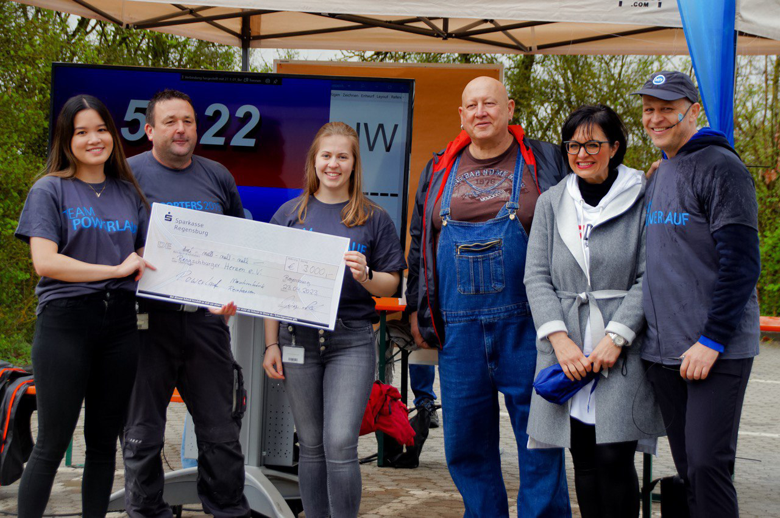
The organizers of the power run hand over the donation check to Arno Birkenfelder (3rd from right) and Monika Hölzl. (2nd from right) from the “Rengschburger Herzen”.

