Press Release

Bauer, Markus  Corporate Communications |  | P +49 941 4090-5241  E markus.bauer@reinhausen.com
April 2023 Company

Young professionals start their careers
13 top trainees received their final certificates at MR

At the beginning of March, a new phase of life began for 13 apprentices at Maschinenfabrik Reinhausen (MR). After passing their final exams, they received their certificates from Managing Director Wilfried Breuer. Together with their instructors, the graduates were delighted with an outstanding grade point average of 1.7, which once again speaks for the high quality of training at MR. Eva Kaiser also received an award as the best electronics technician for industrial engineering in the Chamber of Industry and Commerce's district.

Managing Director Wilfried Breuer addressed his words to the 13 trainees during the certificate handover ceremony and emphasized with regard to his own experiences in professional life: "Training and learning never quite come to an end. In today's world, no matter where, no matter what job you look into - the dynamics have increased. Through your good and very good final grades, you've shown that you've got it down with learning and are very well equipped to start your professional life with confidence and joy. Be confident."

Michael Zwirner, Head of HR Business Partner, and Works Council member Dieter Strauß agreed with these words and added: "You are the generation that will soon keep MR running. We think that's great!"

On behalf of the trainers, Stefan Thür, MR's training manager, also expressed his thanks for the excellent human interaction and the strong performance during the training period. He gave the young professionals the following advice: "Stay curious and committed, continue to develop. You are currently experiencing a time that makes a lot possible and in which you can take on responsibility at a young age due to the order and job situation. I would like to encourage and motivate you to do this. Go your own way, dare to do something - you have already proven that you can do it."

At MR, a total of 107 trainees are currently being prepared for their future tasks in the company in nine industrial and commercial apprenticeships and six dual study programs. As a family-owned company with global operations, MR offers a wide range of development opportunities at home and abroad. The positive personal development of the young people is particularly important to the trainers. Great importance is attached to respectful interaction, flat hierarchies, long-term perspectives and independent action.

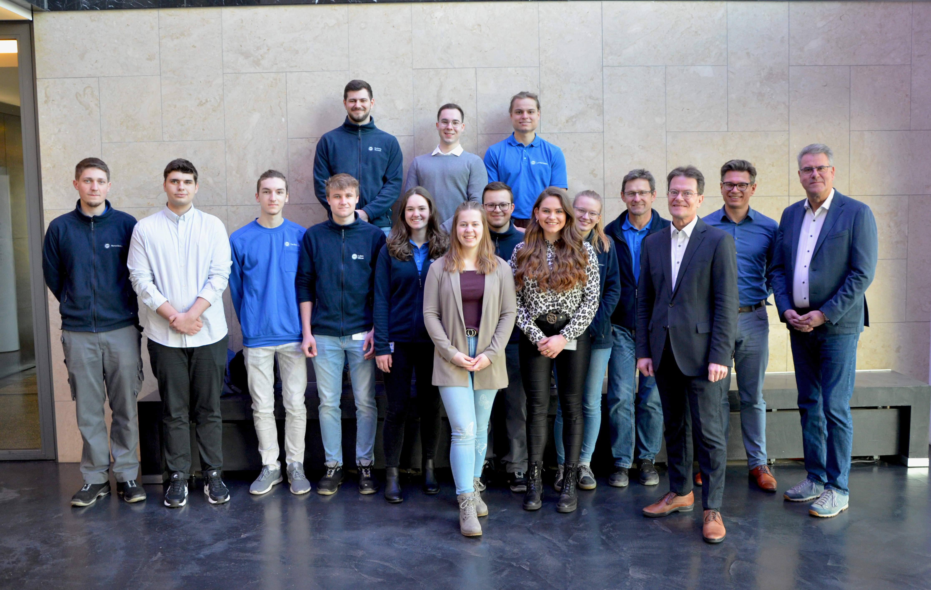
The successful MR trainees with Managing Director Wilfried Breuer (3rd from right),
Training Manager Stefan Thür (4th from right), Head of HR Business Partner Michael Zwirner (2nd from right)
and Works Council member Dieter Strauß (right).

