Press Release

Reichmeyer, Otmar  Corporate Communications |  | P +49 941 4090-648  E o.reichmeyer@reinhausen.com
November 2022 Company

MR is a founding member of the Open Direct Current Alliance (ODCA)

Maschinenfabrik Reinhausen (MR) is one of the founding members of the new Open Direct Current Alliance (ODCA), which the German Electrical and Electronic Manufacturers' Association (ZVEI) launched on Nov. 3, 2022, with 33 companies from industry, academia and research. The goal is to build a worldwide direct current ecosystem and establish direct current technology across applications. The ODCA, a working group of the ZVEI, follows on seamlessly from the successful DC-INDUSTRIE2 research project, which will be concluded next year, and in which MR is also involved.

More information: reinhausen.com/newsroom/news/mr-is-a-member-of-the-new-odca

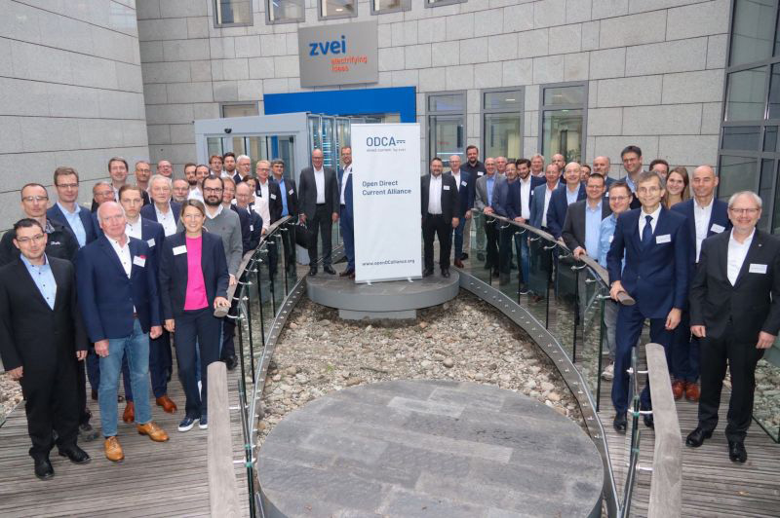
The founding members of the Open Direct Current Alliance.

