Bauer, Markus  Corporate Communications | Phone + 49 941 40 90-5241  markus.bauer@reinhausen.com  www.reinhausen.com
July 2022

The future needs a past – MR honoured 99 anniversaries

Around 150 guests accepted the invitation to the traditional anniversary celebration of Maschinenfabrik Reinhausen (MR) at the Jahnstadion in Regensburg. Together with their companions, they experienced a very enjoyable and entertaining evening in a festive atmosphere. In addition to 61 honors for 10 years and 28 honors for 25 years, nine employees were honored for 40 years of service.
One honor in particular is worth mentioning: the employee Richard Schmid was honored for an impressive 50 years of service.

MR's anniversary celebrations are a firm and very popular part of the company's family culture. MR can look back on an outstanding success story and, within the framework of this event, honors those who have contributed to it for many years or decades – because people make the difference! The employees used this evening to share common experiences and, of course, to intensively discuss the challenges and changes of the future.

Managing Director Holger Michalka also referred to this, placing this celebration under the motto "Future needs origin": "At such get-togethers and occasions, it always becomes clear what an impressive origin we have. Our 99 jubilarians have more than 1,000 years of service between them. With your work and actions in the company, you have decisively shaped the corporate culture. Often it is precisely this corporate culture that differentiates between success and failure as well as top performance and mediocrity," Michalka said in his speech. "Especially in these uncertain times, I would therefore like to encourage you. In your next years of service, please continue to have an appetite for new things, question the existing and continue to give our culture a strong foundation on which we can continue to build our future."

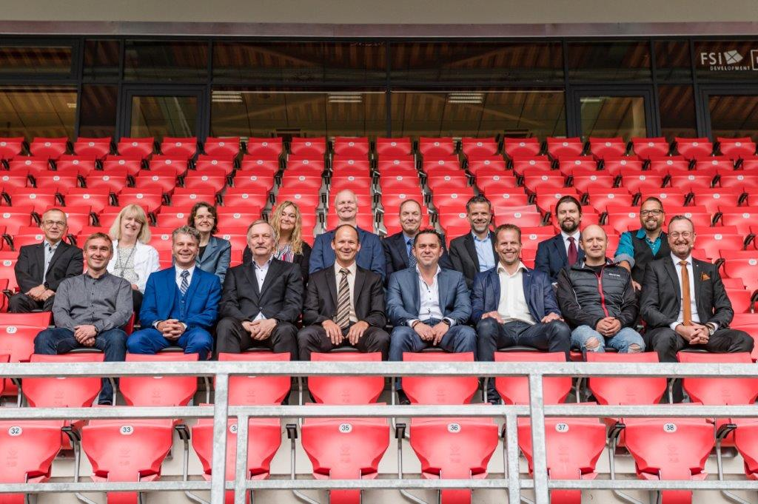
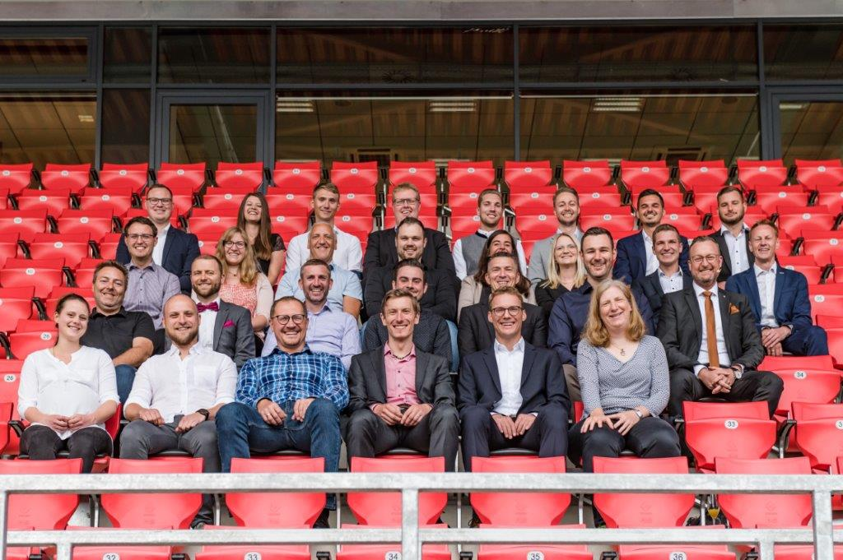
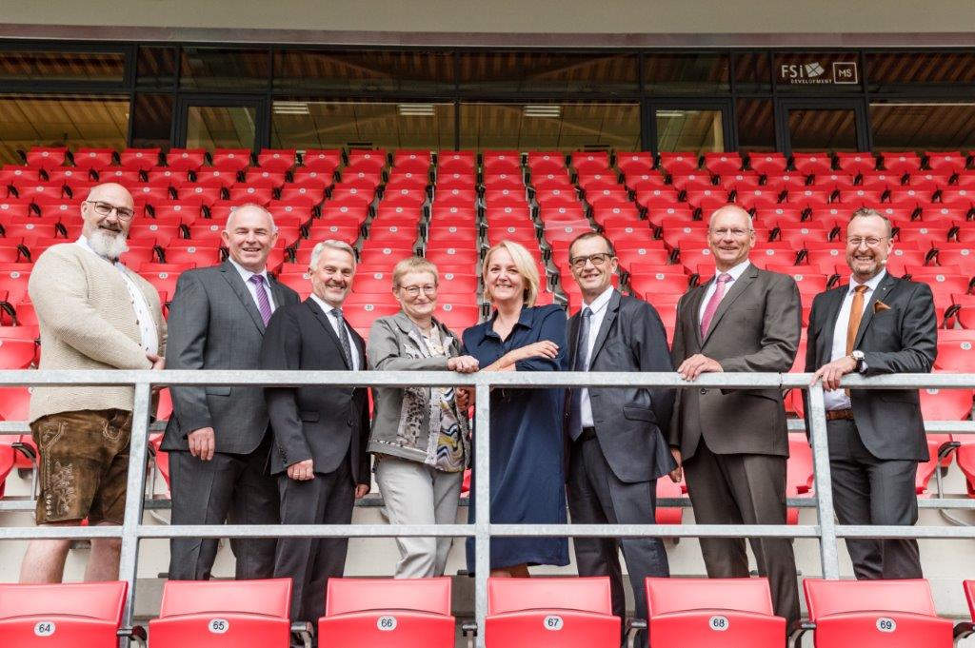
The star guest at the anniversary celebration was the cabaret artist Franziska Wanninger. With her current programme “Für mich soll´s rote Rosen hageln" she had the laughs on her side in no time. The multi-award-winning artist, who "looks people in the mouth and in the heart", went on a search for the full, beautiful life with wonderfully satirical characters. The jubilarians were thrilled by the celebration and the cabaret artist and were happy about the appreciation they received.
Caption: The future needs a past – the jubilarians present for 10 years (left), 25 years (centre) and 40 years (right) of service were pleased with Managing Director Holger Michalka about the appreciation and the successful jubilee celebration.

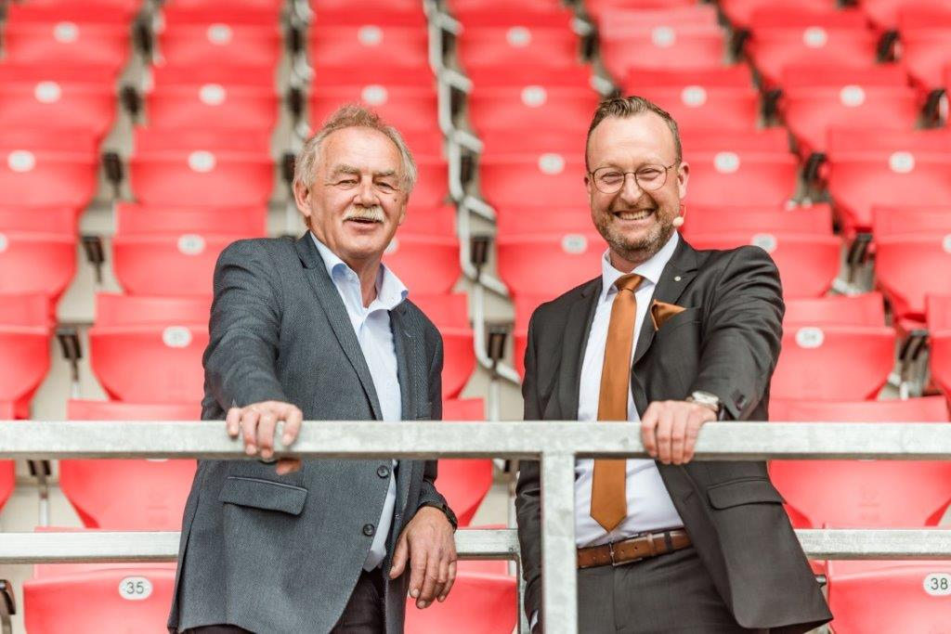

Caption: A very special honor: Richard Schmid (left) was honored by Managing Director Holger Michalka for an incredible 50 years of service.

Picture credits: Petra Homeier Fotografie

