Press Release

Bauer, Markus  Corporate Communications |  | P +49 941 4090-5241  E markus.bauer@reinhausen.com
July 2022 Company | Events | Products and Services | Projects

Digitalization turnaround

With its ISM® platform, MR offers transformer manufacturers an open platform for transformer digitalization and supports them in becoming solution providers

Electricity grid operators are in the midst of a turning point: To ensure the stability of grids, they have to master complex modernizations of technology and infrastructure, for which intelligent transformers play a central role. To enable transformer manufacturers to meet these growing demands, MR now offers the ISM® platform which is an open, manufacturer-independent key technology for digitizing power transformers in which all data collected via sensors converges and which includes a freely configurable control system. In addition to monitoring individual transformers, important information for fleet control can be generated from the bundled evaluation across the entire fleet, thus allowing asset managers to perform condition-based maintenance, for example.

Advising the integration and development of additional services
The ISM® system is housed in a control cabinet in which all applications and functions are integrated, and all the data from the various installed sensor units converge. At the same time, the system serves as an open platform on which additional sensors can be connected in an uncomplicated manner, regardless of the manufacturer. As part of this new offering, MR also offers transformer manufacturers advice and support in developing their individual configurations. Once all technical and design specifications have been defined, MR produces the complete system in its own plant in Regensburg and delivers it just-in-time.

Jürgen Ach, Director of Automation at MR explains: "We can help transformer manufacturers transform themselves from system integrators to solution providers while becoming less dependent on subsystem suppliers such as sensor manufacturers. That's why we don't offer individual components but rather an open, manufacturer-independent platform on which they can compose their own solutions. This open principle means that we also install sensors from third-party manufacturers for OEMs. We also support them in developing their own software modules on the ISM® platform thereby enabling them to differentiate themselves from their competitors with an individual range of products and services."

Sebastian Hilmer, Head of OEM Cooperations, adds: "With the increasing demands on the energy grid as well as the growing amount of available sensor data, the need for intelligent algorithms is also growing. We develop these together with our customers and support them in opening up new business models - such as linking temperature and weather data to create an intelligent fan control system." OEMs save time and money by integrating all sensor technology and functions on one platform and by being able to add their own software to the system independently. Jürgen Ach adds, "A digital transformer is nevertheless a high cost factor. We want to be the ones to scale this concept - which means ensuring more affordable prices through high volumes - so that all OEMs can invest in digital systems."

Hungarian manufacturer relies on MR’s ISM® platform for its GANZ Intelligent Solutions
GANZ Transformers and Electric Rotating Machines Ltd. and Maschinenfabrik Reinhausen (MR) entered into a cooperation agreement in April 2022 for the development and production of intelligent transformers. As a Hungarian pioneer in transformer technology, GANZ is thus positioning itself as a digital solution provider and will consistently rely on MR's proven digitalization platform in the future. The aim of the cooperation is for both sides to become market leaders in regard to the manufacture of more efficient and sustainable transformers. Jan Prins, CEO at GANZ, says: "for new transformers, we are experiencing an increasing demand for sensors and evaluation systems. The collaboration with MR is therefore the first step for GANZ to develop a complete portfolio of smart solutions for all products and offer our customers the benefits of digitized transformers. In the medium term, we therefore not only want to be a system integrator, but also to offer our customers superior automation and digitization solutions."

ISM® platform
Based on the ISM® platform, which combines all of the know-how that MR has accumulated over the decades, manufacturers can easily integrate any sensors or software. All available data thus flow together via fiber optics into the central ISM® computing unit, where they are evaluated and assessed by means of algorithms. Depending on requirements, six different software modules are available, and the computing center, sensors, connections and cabling are all integrated in the control cabinet, thereby avoiding the need for several separate control cabinets and enabling the retrofit of additional modular functions. The ISM® platform thus creates the basis for networked transformers.

Maschinenfabrik Reinhausen GmbH
Regensburg-based Maschinenfabrik Reinhausen GmbH (MR) is successfully active in global niches of electrical power engineering with 45 subsidiaries and 4 associated companies, and 50% of the electricity generated worldwide is regulated by MR products. Founded in 1868, the company is majority family-owned in the fifth generation. In the past fiscal year, 3,500 employees generated sales of 750 million euros. Known as the innovative inventor of the on-load tap-changer, Maschinenfabrik Reinhausen has introduced the ISM® platform and developed ETOS®, the first open operating system for power transformers.

More information: reinhausen.com/impulses/customer-variance-and-globalization-in-transformer-production/digitalization-turnaround-ganz-intelligent-solutions-relies-on-cooperation-with-mr

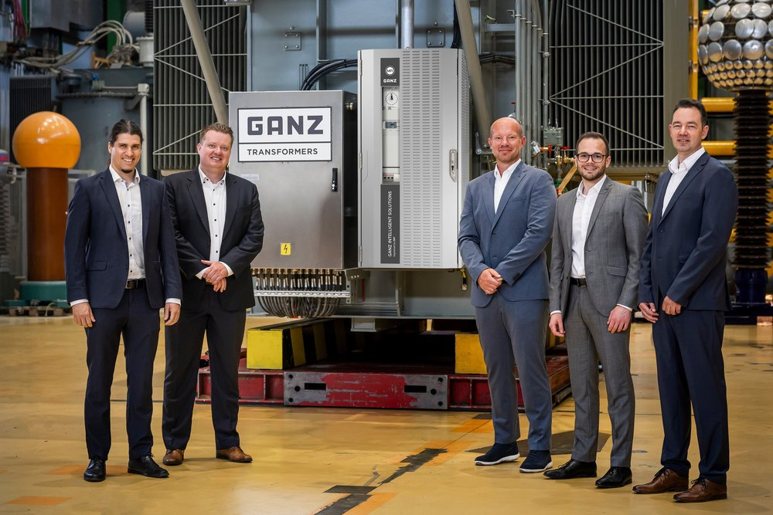
Proudly presenting the first transformer digitalized with the ISM platform from the production of GANZ Transformers (from left): Gábor Farkas and Jan Prins as well as the representatives of Reinhausen Herbert Schubert, Sebastian Hilmer and Totmarton Balazs.
OEMs can save time and money through the integration of all sensors and functions on a single platform and the ability to add their own software to the system.

