Press Release

Bauer, Markus  Corporate Communications |  | P +49 941 4090-5241  E markus.bauer@reinhausen.com
July 2022 Company | Events

Apprenticeship Day at Maschinenfabrik Reinhausen

After a long break, the Apprenticeship Day at Maschinenfabrik Reinhausen was held in July for the first time again in the presence of the training and further education center in Haslbach.

Around 150 potential young employees and their parents were welcomed in person at the education and training center. All those interested had the opportunity to get an idea of the apprenticeships and dual study programs offered at MR. The program included various stations at which the visitors were introduced to different apprenticeship occupations, the company, and the post-apprenticeship prospects. In addition, authentic training videos provided concrete insights into the activities during the apprenticeship. In presentations, the young professionals received all the important information and valuable tips on the subjects of application, the application process and interviews. Another highlight was the opportunity to ask current MR apprentices about the activities and content of their professions, the requirements and, of course, their personal experiences. Questions regarding the choice of profession were answered, as well as questions about possible previous knowledge and challenges. In this way, the young visitors received first-hand information and insights into everyday working life.

All the instructors were very pleased with the great interest and positive feedback: "In many conversations, we found out that our apprenticeship program enjoys an excellent reputation. We invest a lot of time and heart and soul in our apprentices and strive to ensure that their apprenticeship provides them with the best possible foundation for their future careers," said Stefan Thür, head of training. Maschinenfabrik Reinhausen currently employs a total of 105 apprentices in 11 industrial and commercial apprenticeships & dual study programs. For the next apprenticeship year, the company has advertised 35 apprenticeship positions in 11 industrial and commercial apprenticeships and dual study programs for the Regensburg location on the company website reinhausen.com/career/school-students.

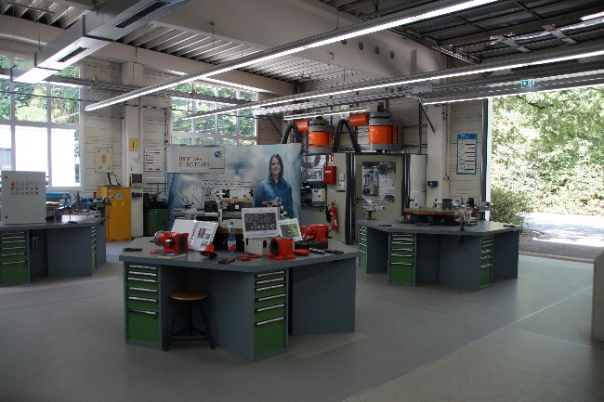
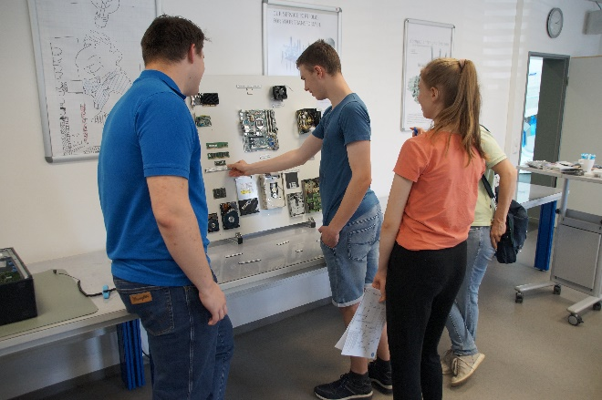

At various stations, apprenticeship professions were presented and insights into the activities and perspectives were given.

