Press Release

Bauer, Markus  Corporate Communications |  | P +49 941 4090-5241  E markus.bauer@reinhausen.com
August 2022 Company

Reinhausen Group acquires ADVANCED TESTING SYSTEMS INC.

Effective August 1st, 2022, Maschinenfabrik Reinhausen GmbH (MR) acquired the shares of ADVANCED TESTING SYSTEMS INC. located in Bethel/Connecticut, USA.

The company was founded in 1982 and offers electrical tests and service work on medium and high voltage test equipment, mainly in the US states of Connecticut, New York, and New Jersey, but also in the rest of the USA, Canada, and Mexico.

The acquisition will enrich MR and its subsidiary HIGHVOLT Prüftechnik Dresden GmbH (HV) by experienced engineers and technicians, specialized equipment, and well-established customer relations within the high voltage industry in the USA. Through combined competencies as well as shortened answer and travel times we aim to improve our after-sales-services to central- and north American customers, such as transformer and cable manufacturers. Mr. Donald Patrick MacCarthy will continue to serve ADVANCED TESTINGS SYSTEMS INC. as General Manager.

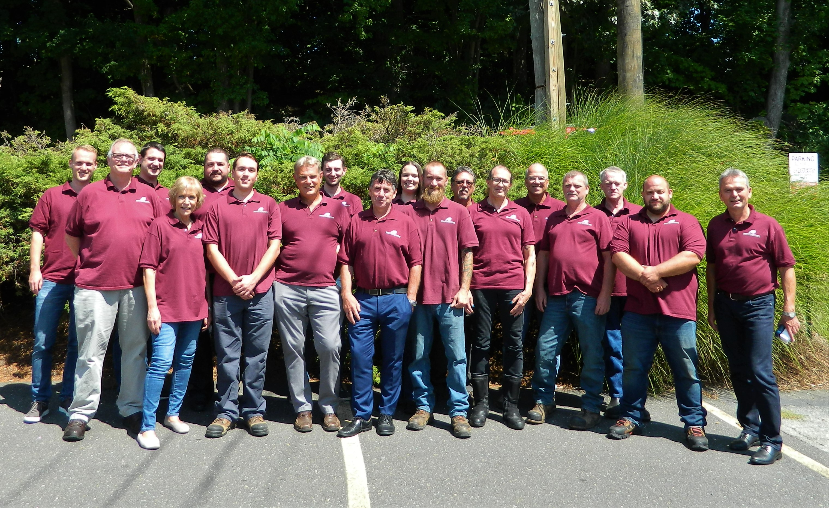

The team of ADVANCED TESTING SYSTEMS INC. together with representatives of Maschinenfabrik Reinhausen und HIGHVOLT Prüftechnik Dresden GmbH.

